**AWS Task-1**

**Task Description:**

Create a windows Vm machine in AWS and connect with RDP open CMD in windows share the about system info..

**Solution :**

**✅ Launch a Windows VM(Virtual MACHINE) in AWS**

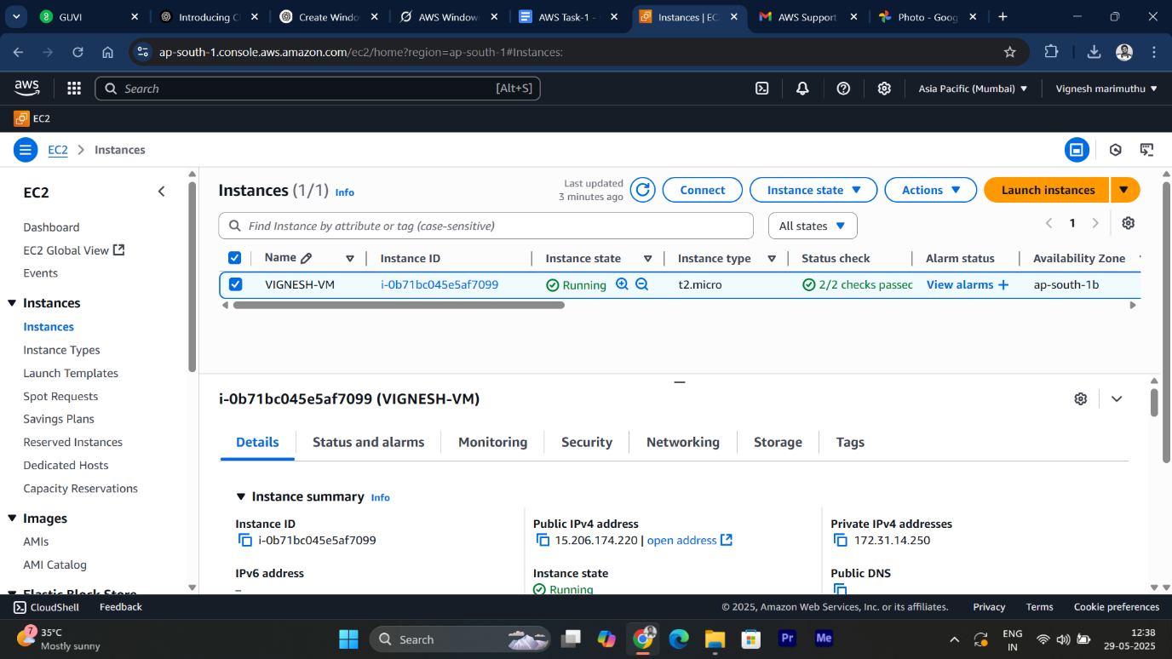

* Launched the **instance (VM)** successfully.

**✅ Connect to Windows VM using RDP**

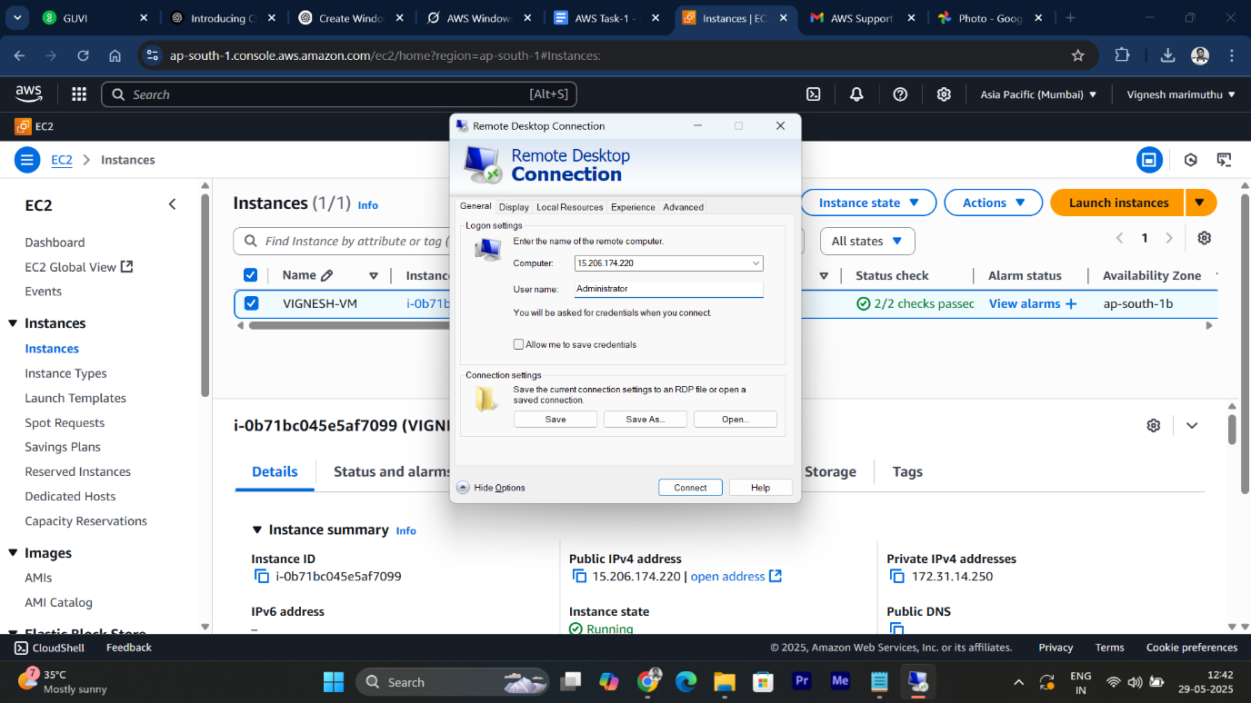

* After the instance was running, I **Connected → RDP Client**.
* **Decrypted** the administrator password using the **.pem key.**
* Opened **Remote Desktop Connection (RDP)**
* Connected to the **VM(Virtual Machine)**

**✅ Open Command Prompt and Share System Information**

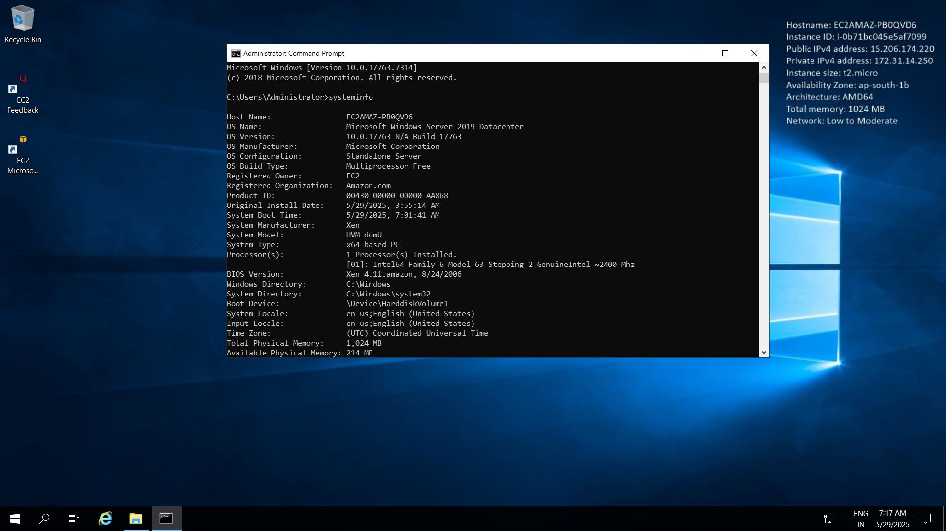

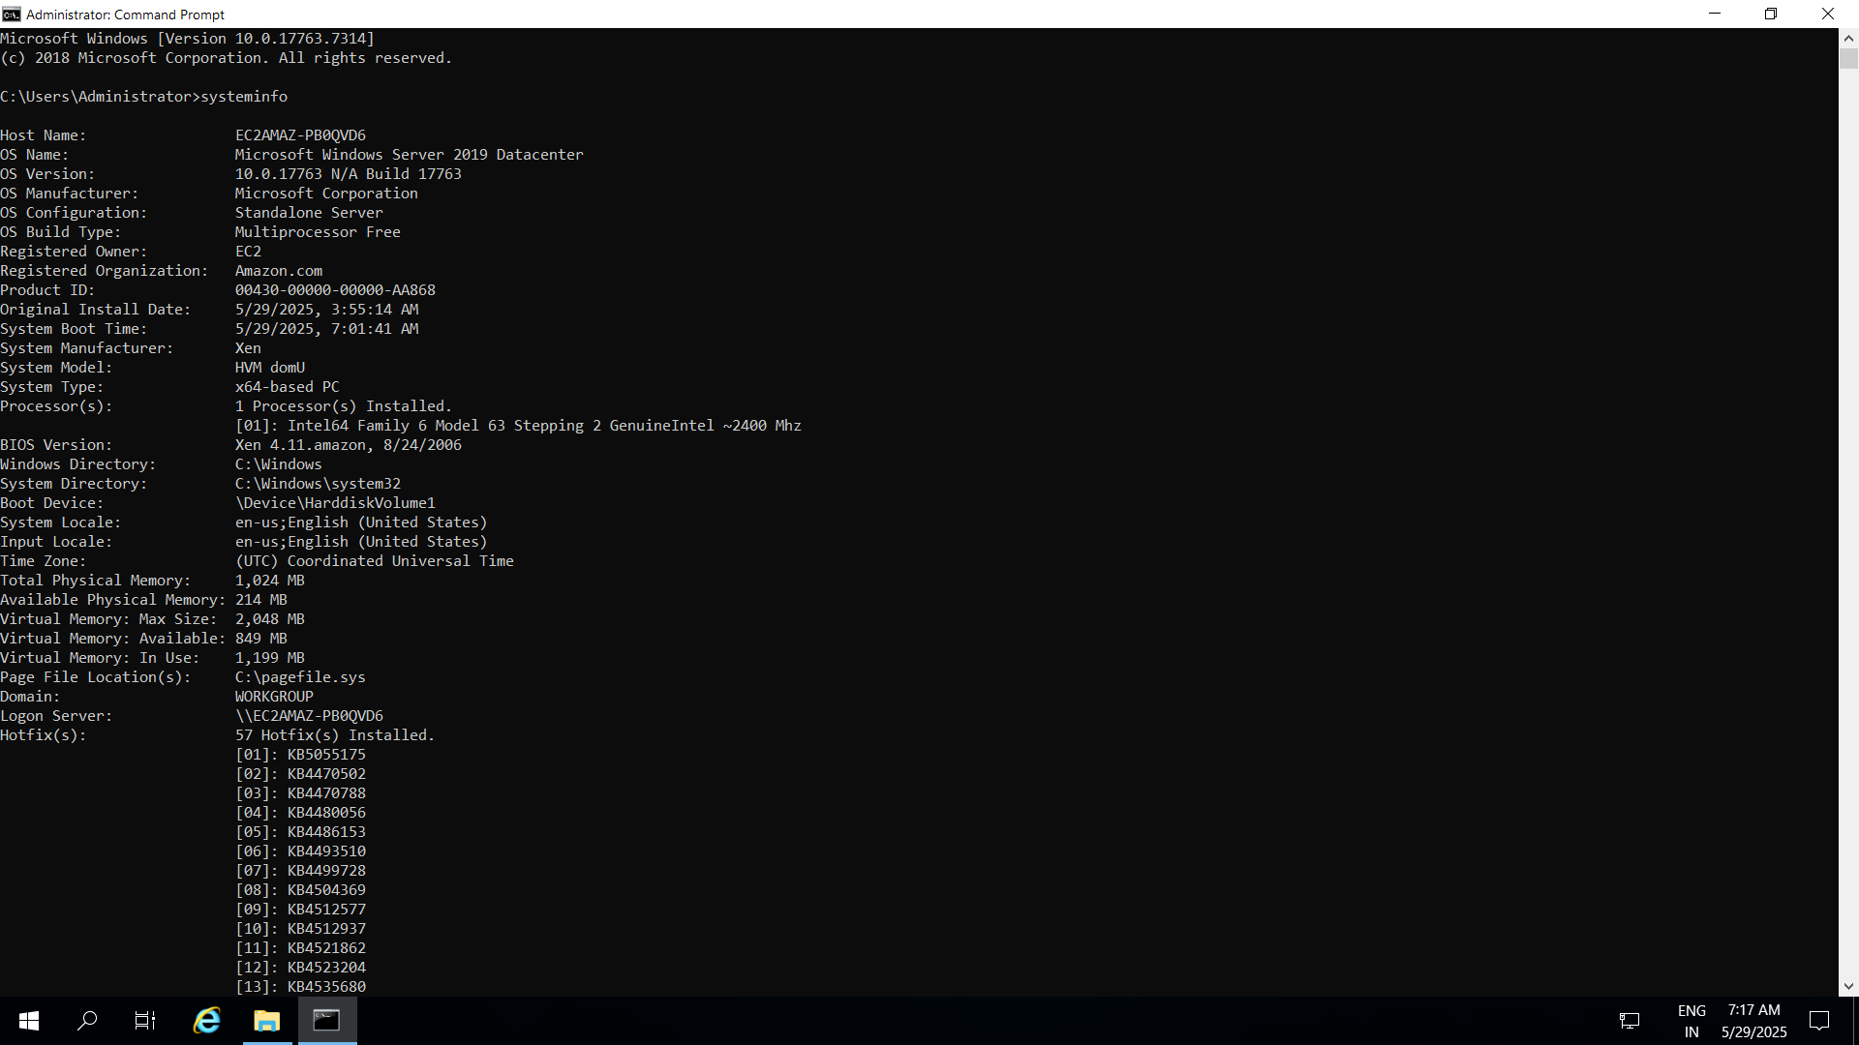

* Opened **Command Prompt (CMD)**.
* To displays detailed system information : **systeminfo**
* **Output included** OS version, system manufacturer, memory, network configuration, etc.